Registration Form

Name of Child:______________________

Date Received:_______________________

Start Date:__________________________

End Date:___________________________
Office use only

Date and Reason for Discharge: _________________________________________________________________________________________________________________________________

Following Forms Completed and on file:

Registration Form ☐Yes ☐No
Identification/Emergency Info ☐Yes ☐No
Health Information ☐Yes ☐No
Immunization Record ☐Yes ☐No
Permission Form ☐Yes ☐No
COHI ☐Yes ☐No
Authorization Form ☐Yes ☐No

Little Eagles Daycare Registration Form

Identification of child/Emergency Information
Name:_____________________________ Band #_____________________
Boy ☐ Girl ☐ Date of birth (day/month/year)________________

Home Address
Street_________________________________________________________
City__________________________________________________________
Province______________________________________________________
Postal Code____________________________________________________
Mailing Address if different than the above address give
Street_________________________________________________________
City__________________________________________________________
Province______________________________________________________
Postal Code____________________________________________________

Language: English☐ Mi’kmaq☐ French☐ Other☐
If there are other languages please list __________________________________________________________________________________________________________________________

Nova Scotia Health Card Number:__________________________________
Health Card Expiry Date__________________________________
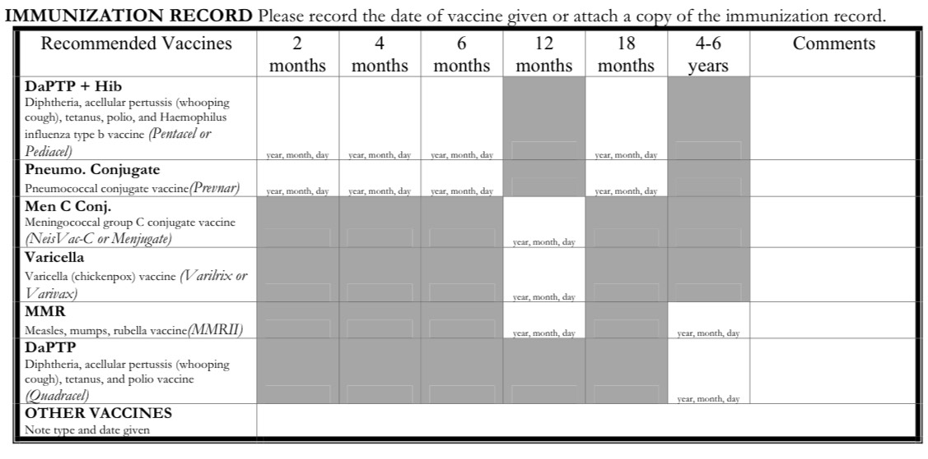

Physician and/or Clinic
Name________________________________________________________
Address:______________________________________________________
Telephone_____________________________________________________

Dentist and/or Clinic
Name________________________________________________________
Address:______________________________________________________
Telephone_____________________________________________________

Parent/Guardian
1.Name: ______________________________ Relationship: ____________
Address: ______________________________________________________
Occupation: ___________________________________________________
Email Address:_________________________________________________
Contact Number
Home | Work | Cell

2.Name: __________________________ relationship: _________________
Address: ______________________________________________________
Occupation: ___________________________________________________
Email Address:_________________________________________________
Contact Number
Home | Work | Cell

Emergency Person to contact if parent/guardian cannot be reached:

Name: _______________________Phone: __________________________

People authorized to pick your child up from daycare:
Name | Phone Number

Start Date for your child________________________________________
Reasons for placing child in daycare:
☐Work
☐Attending School/training
☐Other. Please explain: _________________________________

Will your child be ☐part-time or ☐full-time

If there are no seats available , the child will be placed on a waiting list; parent will be notified once a seat becomes available. Parent(s)/Guardian have two weeks from notification to fill the seat; after that time the next on the list will be notified

All children are welcome at Little Eagles Daycare. Please identify any supports your child may require for meaningful participation in our program. This may also include any supports identified by other professionals (i.e. Speech and language, developmental interventionist's, etc.
Please describe additional supports:
__________________________________________________________________________________________________________________________________________________________________________________________________________________________________________________________________________________________________________________________________________________________________________________________
Child’s Information
Has your child been in a childcare arrangement before ☐Yes ☐No
If your child has been cared for by family members or others (i.e. neighbor), please describe the child’s experiences._____________________________________________________________________________________________________________________________________________________________________________

If your child has had group play experiences, please describe how often your child attended, how long was your child’s experiences: _______________________________________________________________________________________________________________________________________________________________________________________

Health and Developmental History
Describe any difficulties or serious illnesses at birth, if any _______________________________________________________________________________________________________________________________________________________________________________________
Describe your child’s general health (i.e. recurrent colds, ear infections, stomachaches, etc.)
_______________________________________________________________________________________________________________________________________________________________________________________
Are there presently any serious medical problems? ☐Yes ☐No If yes please describe.
_______________________________________________________________________________________________________________________________________________________________________________________
If your child is taking any medication, what type of medication and what is it for? __________________________________________________________________________________________________________________________
Has your child ever been to a dentist? ☐Yes ☐No

Does your child have any dental problems? _______________________________________________________________________________________________________________________________________________________________________________________
Describe how the child communicates: _______________________________________________________________________________________________________________________________________________________________________________________
How would you describe your child’s emotional, physical, intellectual, and social growth and development to this point?
_______________________________________________________________________________________________________________________________________________________________________________________
Describe your child’s diet (include types of food and fluids he or she is now taking)
Fluids/Beverages_________________________________________________________________________________________________________________________________________________________________________
Solids__________________________________________________________________________________________________________________________________________________________________________________
Food Allergies _________________________________________________ _______________________________________________________________________________________________________________________________________________________________________________________

Does your child have any allergies (i.e. Medications, Food, or Environmental and/or contact allergies)? ☐Yes ☐No
If yes, please list : ______________________________________________
_________________________________________________________________________________________________________________________________________________________________________________________________________________________________________________________________________________________________________________
**Does your child require an Epi Pen? ☐Yes ☐No if yes please supply one and ask for a medication permission form. This instance, what does the child typically present with (i.e. swelling lips, shortness of breath, face swelling, hives, etc.) and what type of medication is typically required
_______________________________________________________________________________________________________________________________________________________________________________________
Does your child eat peanut butter at home ☐Yes ☐No
Are there any dietary restrictions for your child?
_______________________________________________________________________________________________________________________________________________________________________________________

Describe any particular concerns you may have about your child’s diet and/or eating habits_______________________________________________________________________________________________________________________________________________________________________________________________________________________________________________

Describe your child’s sleeping habits and routine
_______________________________________________________________________________________________________________________________________________________________________________________
How frequently does your child have a bowel movement?
_______________________________________________________________________________________________________________________________________________________________________________________

Please describe a normal to the child bowel movement (i.e. loose, hard, runny, etc.) _______________________________________________________________________________________________________________________________________________________________________________________

How far has your child progressed in potty training, if applicable?
_______________________________________________________________________________________________________________________________________________________________________________________

Behavior Patterns and Habits
Describe your child’s behavior and habits (i.e. temperament, energy level)
_______________________________________________________________________________________________________________________________________________________________________________________

Describe an ordinary day in your child’s life, from getting up in the morning to going to bed, including times meals, play, interests, activities, etc.
Morning
_______________________________________________________________________________________________________________________________________________________________________________________
Afternoon (Nap time)
_______________________________________________________________________________________________________________________________________________________________________________________
Evening
_______________________________________________________________________________________________________________________________________________________________________________________

Describe your child’s particular attachments (i.e. toy, blanket, pet, person) and any particular habits (i.e. thumb sucking, rocking, fidgeting)
_______________________________________________________________________________________________________________________________________________________________________________________
Describe any particular fears your child has shown (i.e. animals loud sounds, strangers)
_______________________________________________________________________________________________________________________________________________________________________________________

Describe how your child reacts to stressful situations (i.e. cried, withdraws, has tantrums, nightmares).
_______________________________________________________________________________________________________________________________________________________________________________________
How does your child usually react to new situation?
_______________________________________________________________________________________________________________________________________________________________________________________
We would appreciate your views on guiding your child’s behavior and setting limits
_______________________________________________________________________________________________________________________________________________________________________________________

Is there anything else that you would like to tell us about your child to help us provide quality care?
_______________________________________________________________________________________________________________________________________________________________________________________

Little Eagles Daycare
Emergency Medical Consent Form

Though all daycare staff are trained in emergency first aid and CPR and will administer any necessary treatment as required, should a child have an accident during daycare hours, the daycare staff will assess the situation and follow procedures below:
➔If the accident requires medical attention, the daycare staff will contact the parent(s)/guardian(s) immediately for instruction
➔If the parent is unavailable the program staff will contact the alternate emergency contact(s) for instruction
➔If neither the parent(s)/guardian(s) nor the alternate emergency contact is available the daycare staff will call for emergency transport as the daycare staff may not transport any child in their personal vehicle
➔If the accident is identified as needing immediate assistance emergency transport will be called first and then the parent(s)/guardian(s) or alternate emergency contact will be called

Program staff may not be able to right with a child in the emergency transport vehicle but will travel to the hospital in the event the parent or emergency contact cannot be reached

I hereby grant permission to the Little Eagles Daycare staff to take the above listed steps in the case of an accident. The authorization agreement will stand from this day until the termination of the child’s attendance in the program

____________________________ ____________________
Signature of Parent/Guardian Date
Little Eagles Daycare
Permission slips

Outings
☐I give permission for my child to go on outings within the community with the Little Eagles Daycare Staff

☐I do not give permission for my child to go on outings within the community with the Little Eagles Daycare Staff

Facebook
☐I give permission the Little Eagles Daycare staff permission to take pictures of my child while at Daycare and post them the Little Eagles Daycare Group.
☐I do not give permission the Little Eagles Daycare staff permission to take pictures of my child while at Daycare and post them the Little Eagles Daycare Group.

★★Little Eagles Daycare Facebook Group is private and is strictly for parents/guardians and Staff ONLY★★
_____________________________________________________________

Smudging
The Little Eagles Daycare will be introducing “Smudging” to the little people as part of our Cultural Activities. Because of our Diverse Community and some people have sensitivity issue. We require your permission to have your child participate.

☐YES, I would like my child to participate in smudging.
☐NO, I would not like my child to participate in smudging.

____________________________ ____________________
Signature of Parent/Guardian Date
Little Eagles Daycare
Authorization Form

☐I acknowledge that I have received and read the Little Eagles Daycare Handbook/Policies
☐I hereby grant permission for my child to use all the play equipment and participate in all aspects of the program offered at the Little Eagles Daycare
☐I acknowledge that I have completed the following forms and submitted them to the Little Eagles Daycare
➔Registration Form
➔Identification and Emergency Form
➔Immunization Record
➔Health and Development History
➔Behavior Patterns
➔Consent Forms
➔Permission Slips
➔Children’s Oral Health Initiative

☐I hereby acknowledge that I have read and agree to the following guidelines and policies for the Little Eagles Daycare

Child’s Name: _________________________________________

Parent/Guardian (please print): ____________________________

Signature of Parent/Guardian: _____________________________

Date: _________________________________________________

Signature of Manager: ___________________________________

Date: _________________________________________________

